Exercise 4: Creating and Configuring a Maven Project

Scenario: You need to set up a new Maven project for the library management application and add Spring dependencies.
Steps:
1. Create a New Maven Project:
- Create a new Maven project named LibraryManagement.
2. Add Spring Dependencies in pom.xml:
- Include dependencies for Spring Context, Spring AOP, and Spring WebMVC.
3. Configure Maven Plugins:
- Configure the Maven Compiler Plugin for Java version 1.8 in the pom.xml file.

IMPLEMENTATION:
Step 1: Create a New Maven Project
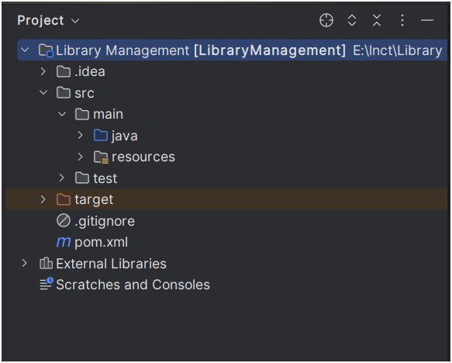
Step 2: Add Spring Dependencies in pom.xml

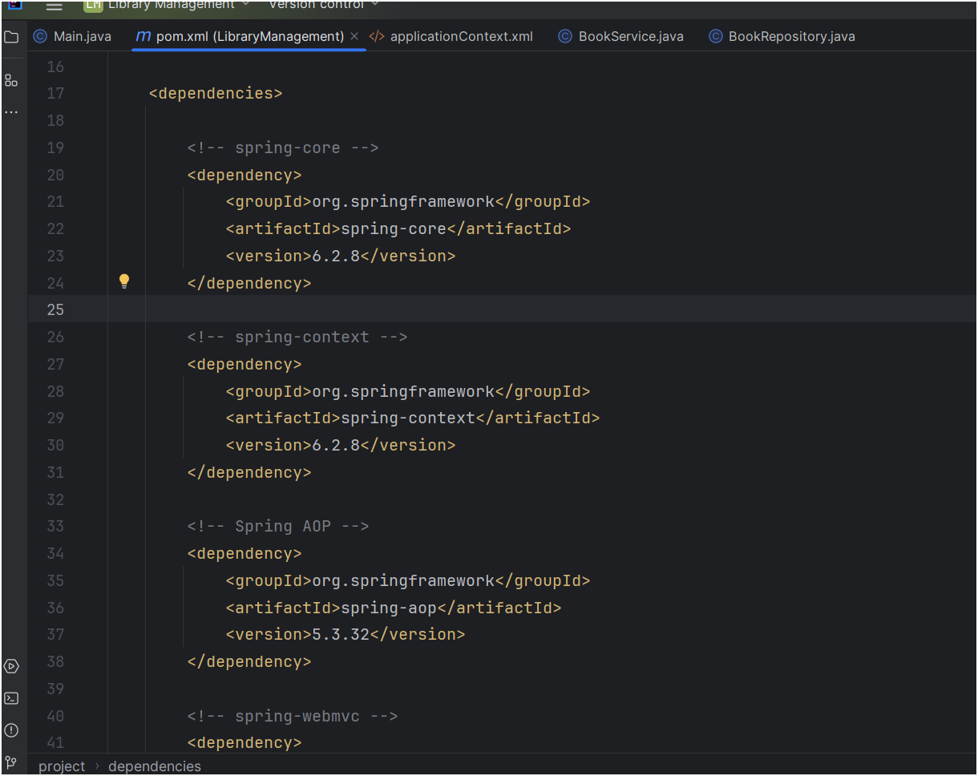

Step 3: Configure Maven Compiler Plugin

